**2020**

**Chapter 4 –McKenzie Subbasin**

Table of Contents

1. McKenzie sub-basin Overview 1

2. Facilities 5

2.1. Cougar Dam 5

2.2. Blue River Dam 7

2.3. Cougar Fish Facility 7

3. Dam Operations 7

3.1. Flow Management 7

3.2. Downstream Fish Passage 9

3.3. Water Quality Management 10

3.4. Spill Management 11

4. Dam Maintenance 11

5. Fish Facility Operations 11

5.1. Juvenile Fish 11

5.2. Adult Fish 11

6. Fish Facility Maintenance 15

7. Inspections, Reporting, and Notifications 15

8. Dewatering plan 17

9. Forebay Debris Removal 19

## McKenzie sub-basin Overview

* 1. The McKenzie River is about 90 miles long and drains an area of about 1,340 square miles (Figure MCK-1). Two U.S. Army Corps of Engineers (USACE) dams were constructed in the McKenzie subbasin – Cougar Dam at river mile (RM) 4.4 on the South Fork McKenzie River was completed in 1963 and Blue River Dam at RM 1.8 on the Blue River was completed in 1968. Multiple smaller diversions/canals and some higher dams are located on the McKenzie River including Leaburg Dam (RM 29) and the Carmen-Smith Hydroelectric Project (RM 82), both owned and operated by the Eugene Water and Electric Board (EWEB). Leaburg Dam was outfitted with new ladders and a screened diversion intake in 2002-2003.
  2. The subbasin is inhabited by Endangered Species Act-listed Upper Willamette River (UWR) spring Chinook salmon and bull trout, as well as recently delisted Oregon chub.

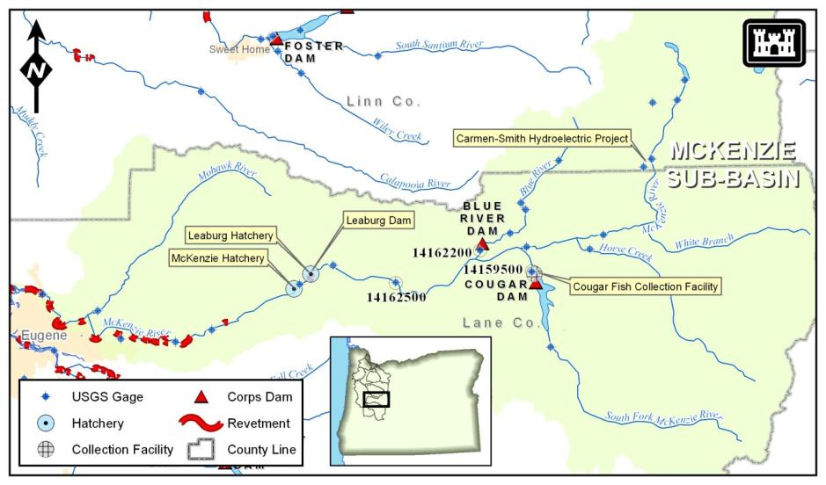

Figure MCK‑1. McKenzie Subbasin

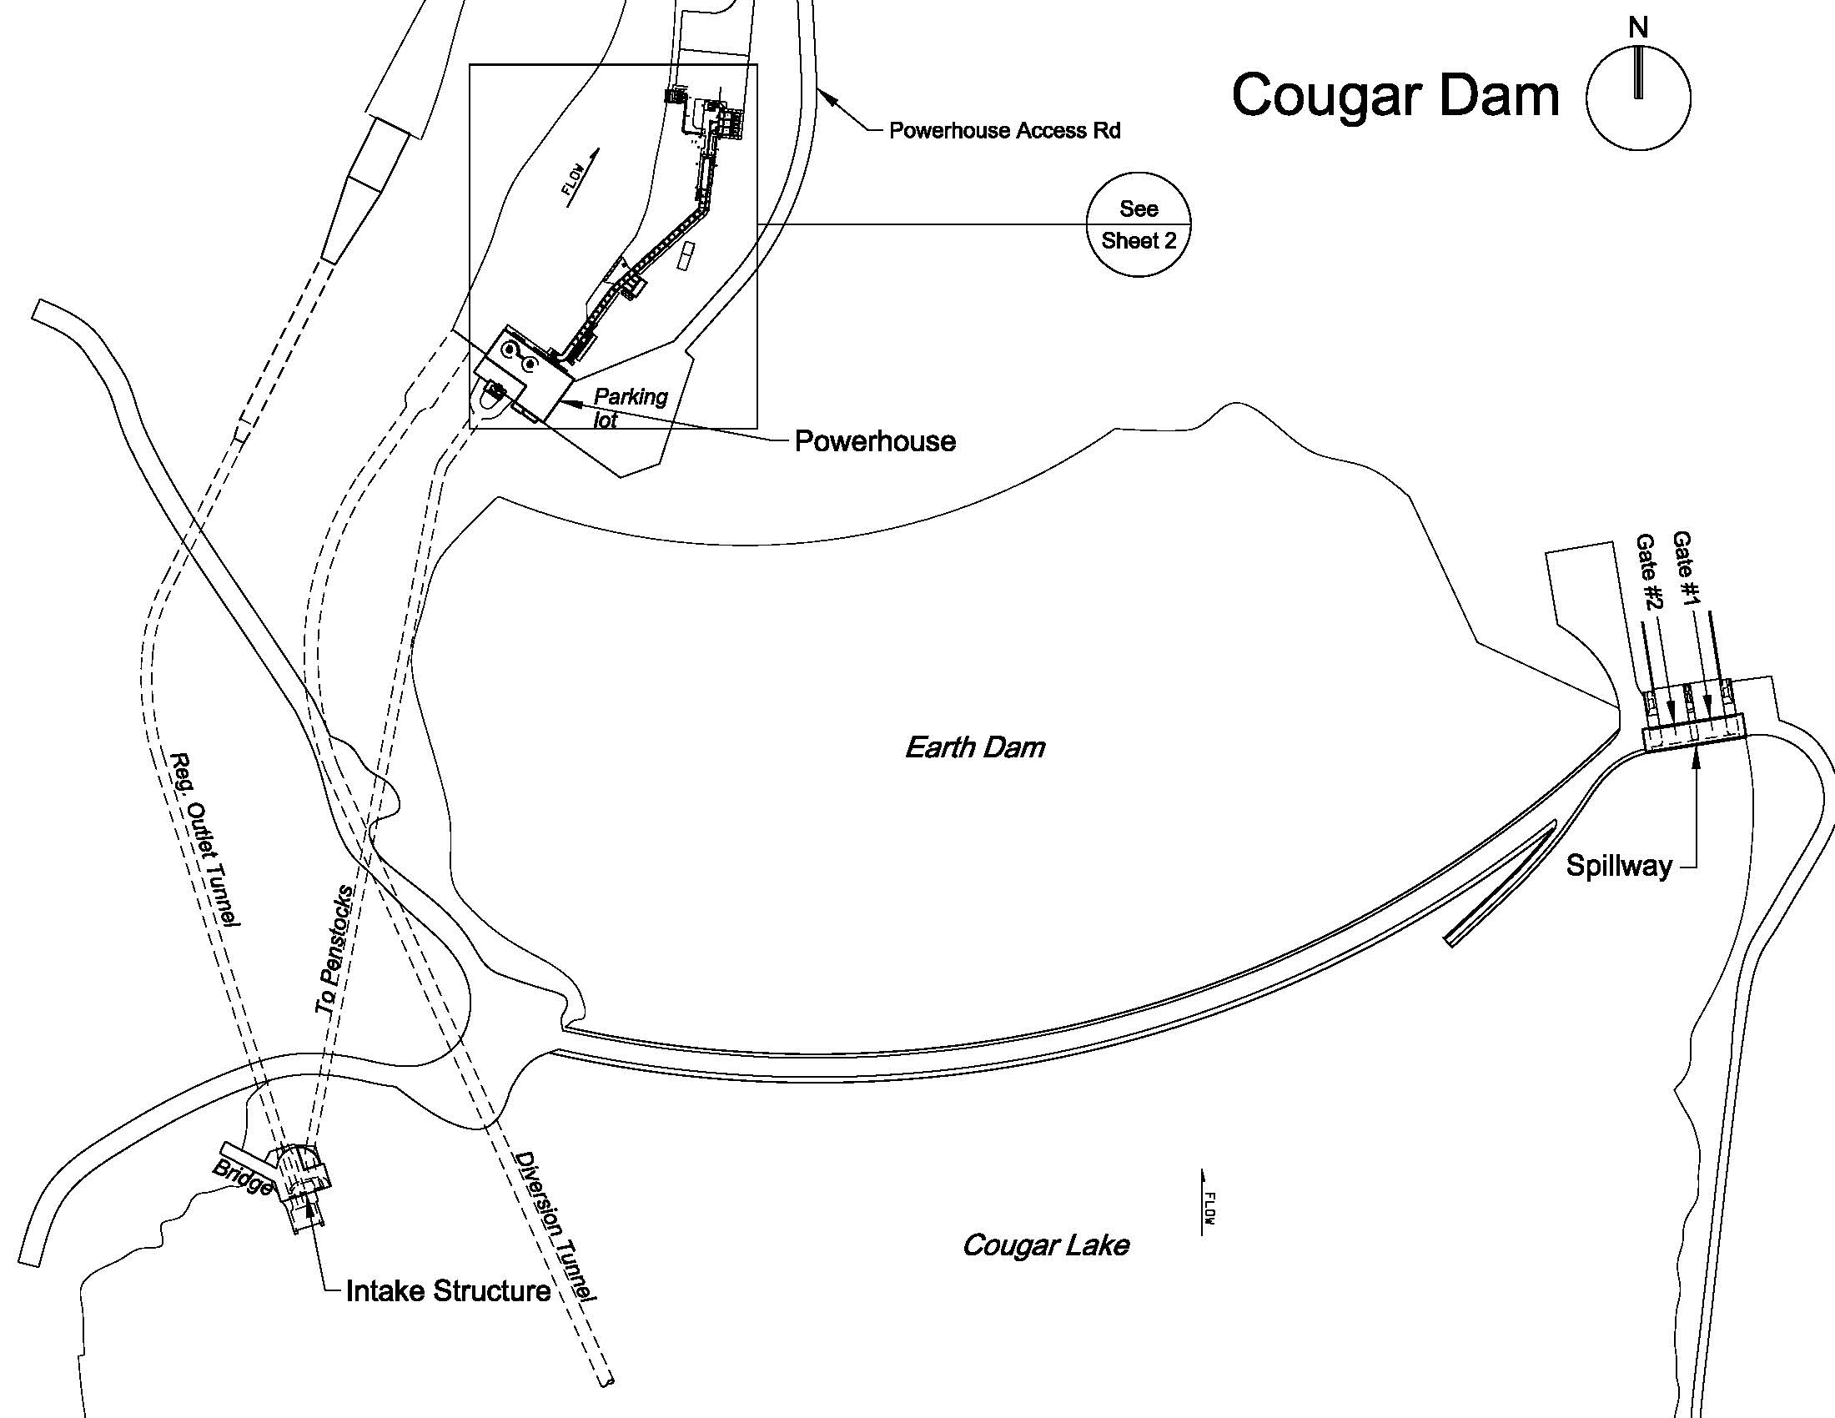

Figure MCK‑2. Cougar Dam

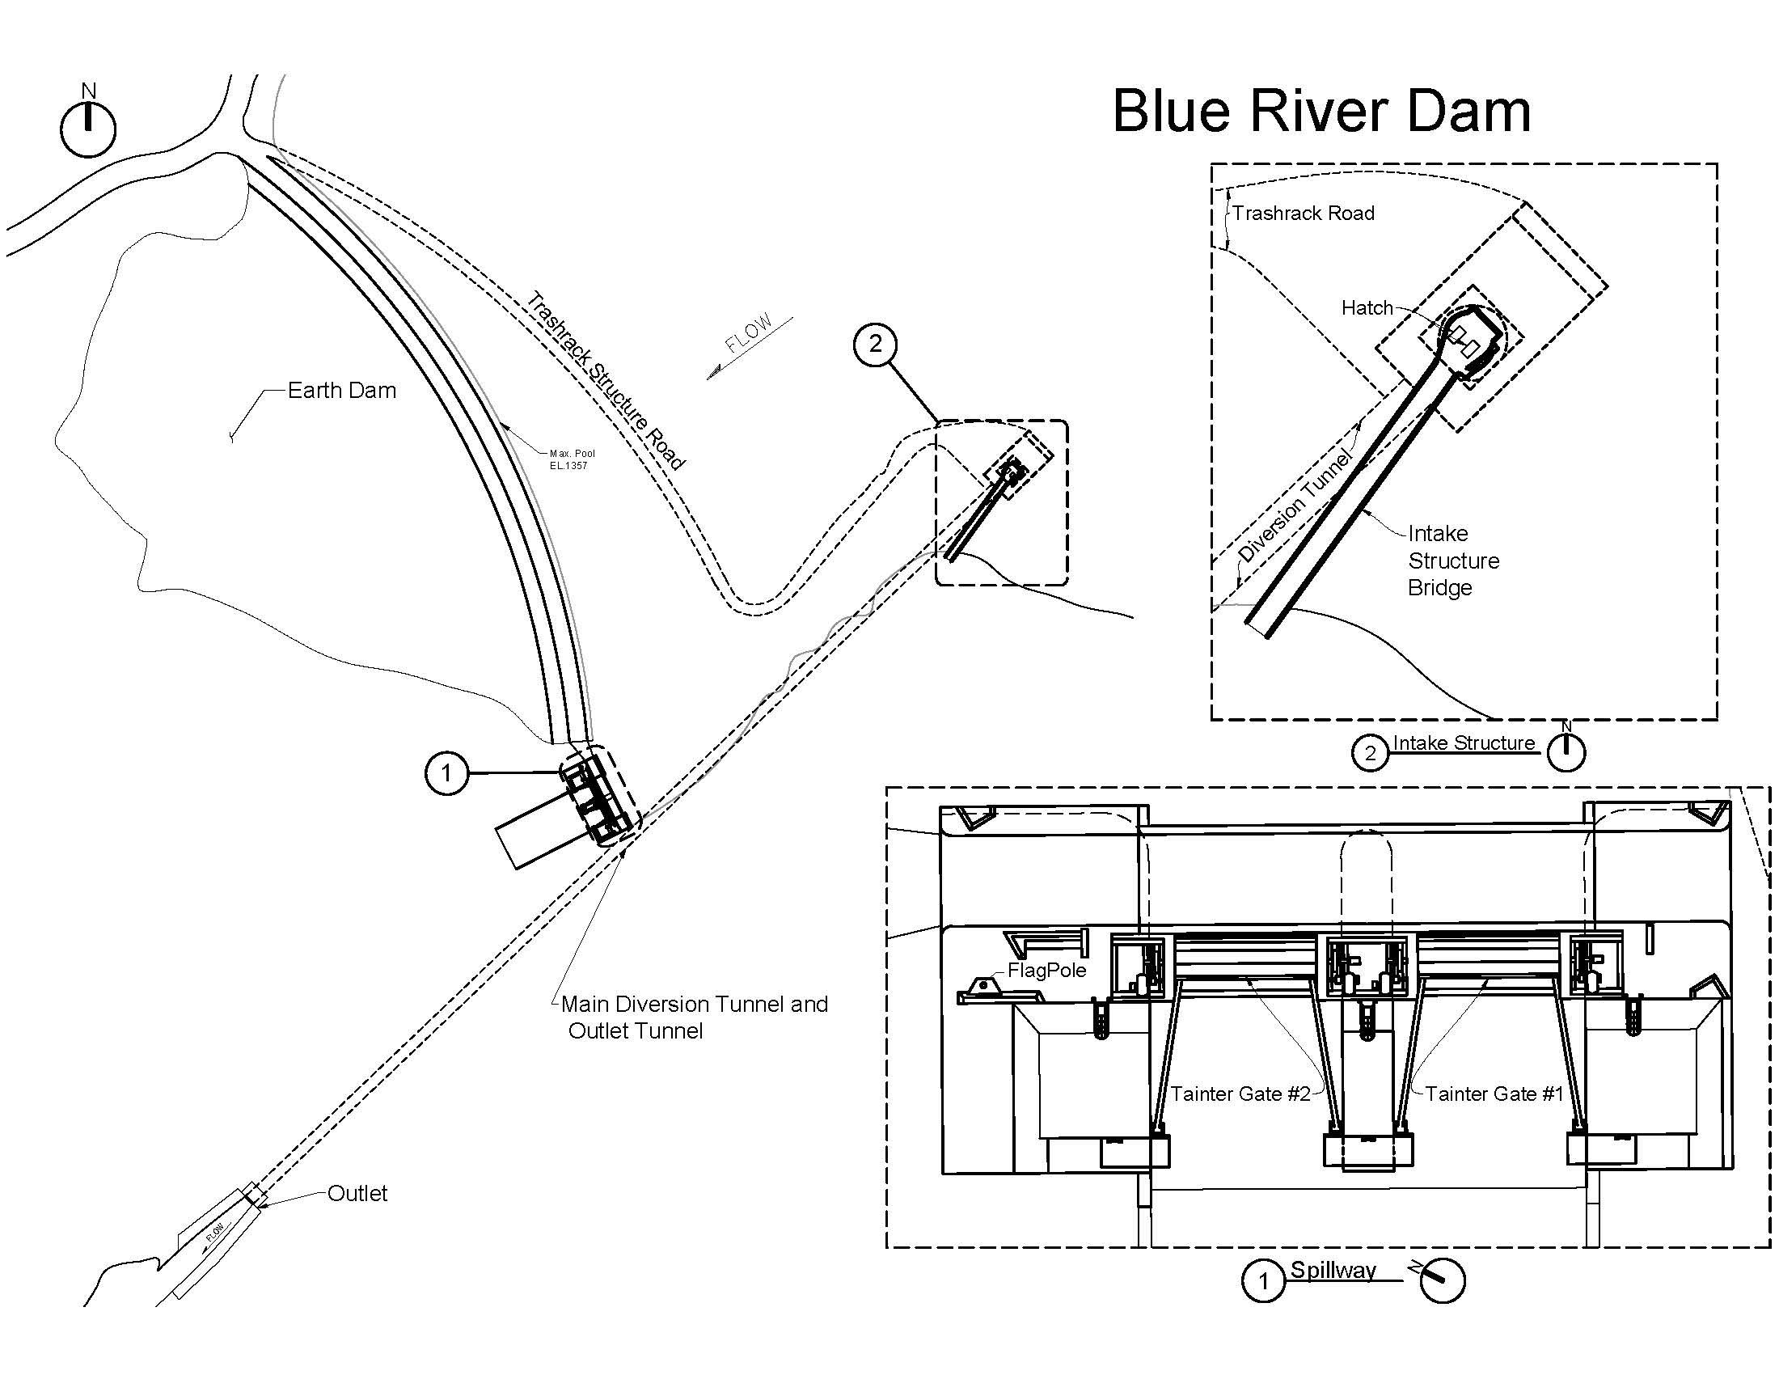

Figure MCK‑3. Blue River Dam

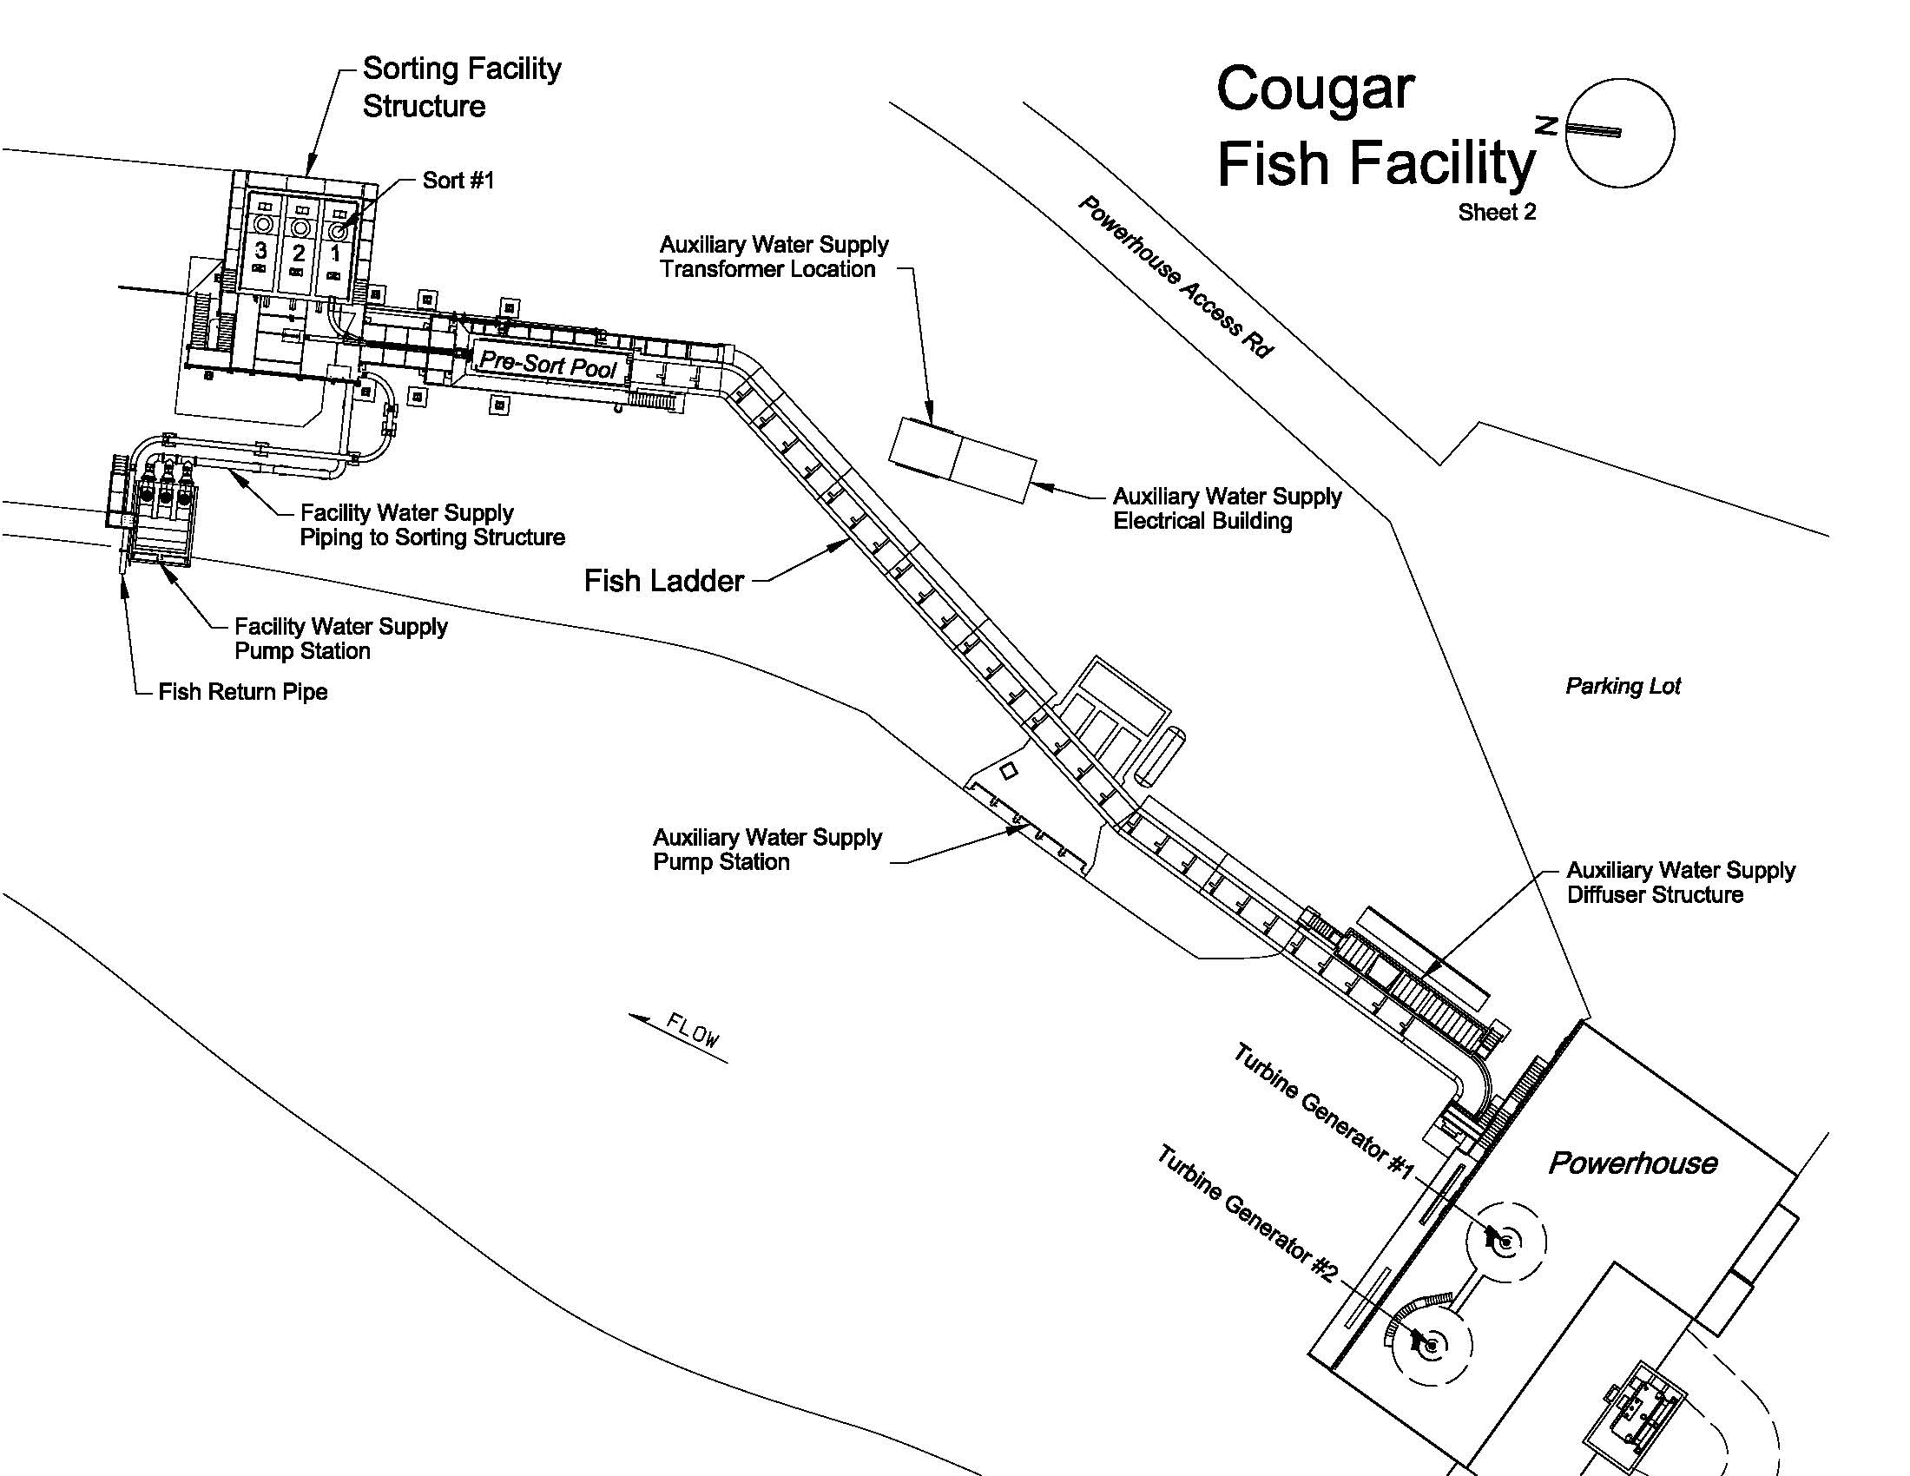

Figure MCK‑4. Cougar Fish Facility

Table MCK‑1. Periodicity Table for Spring Chinook Salmon in the South Fork McKenzie River below Cougar Dam.



## Facilities

Cougar and Blue River are the two Willamette Valley Project (WVP) dams located in the McKenzie subbasin. The USACE completed construction of Cougar Dam on the South Fork McKenzie River in 1963 and Blue River Dam on Blue River in 1969.

Cougar and Blue River dams are operated remotely from the Lookout Point control room. The precision of the Supervisory Control and Data Acquisition (SCADA) system controls are not finely tuned enough to adjust the amount of water through the projects to meet small flow changes as required by the project schedule. Additionally, there can be a lag time (30-60 minutes) from when an operational change is made at Cougar or Blue River dams and when the control room observes the change recorded at the nearest downstream U.S. Geological Survey (USGS) gages #14162200 (Blue River at Blue River) or #14159500 (South Fork McKenzie near Rainbow).

### Cougar Dam

Cougar Dam is a multi-purpose storage project that operates to meet authorized purposes of flood damage reduction, irrigation, power generation, recreation, navigation, municipal and industrial water supply, and downstream water quality improvement. The dam is a rock-fill structure with a powerhouse, concrete spillway with two tainter gates, and two slide gate regulating outlets (ROs). The dam is about 1,600-feet long and 450-feet high from average tailwater to the dam crest. The RO and penstock tunnels have a common intake structure in the left abutment. The outlet capacity is 6,000 cubic feet per second (cfs) at minimum flood control pool (elevation 1,532 feet). The power plant has a capacity of 25 megawatts (MW) and is located at the toe of the rock-fill dam. A water temperature control (WTC) structure began operation in May 2005. A diversion tunnel used during construction of the WTC structure is an additional outlet but is not designed for routine use. Outflow is primarily released through the powerhouse and ROs.

#### Turbines

The intake to the penstock from the WTC wet well is an 8-foot, 2-inch by 10-foot, 6-inch rectangular section with a transition between the intake and penstock. The 10-foot, 6-inch diameter main penstock is 1,030 feet long in rock. The penstock at the lower end branches into two 7-foot, 6-inch diameter conduits which lead to the turbines in the powerhouse. Cougar has two Francis turbines rated at 12.5 MW each. The hydraulic capacity through the turbines ranges from 650 to 1,100 cfs depending on head. The head of the turbines varies from a minimum of 266 feet, between normal tailwater and minimum power pool, and a maximum of 449 feet, between tailwater and maximum or full pool. Turbines are adjusted by making changes to the wicket gate openings. Small flow changes can be difficult due to wicket gate limitations.

#### Spillway Gates

The dual tainter gate ogee-type spillway has a net crest length of 80 feet and is located in the right abutment. The spillway has a discharge capacity of 76,140 cfs at maximum pool (elevation 1,699 feet), with the gates fully open. The spillway discharges into a 90-foot-long chute with no stilling basin. Interim risk reduction measures (IRRMs) are being implemented at Cougar Dam to address concerns with tainter gate stability. The use of the spillway is reserved only for extreme emergencies.

#### Regulating Outlets

Cougar Dam has two ROs that are controlled with vertically sliding gates from the Lookout Point control room or locally. There is only one speed that the RO gates can be opened or closed. A staff gage is used to measure the opening locally. Readings on the staff gage are spaced at 0.1 foot and the SCADA dial is set to 0.01-foot increments. The precision of the gate adjustments limit fine-tuning RO flows. The dam’s RO gate #2 currently has a set point of 1 foot in case the turbine wicket gate opening goes to zero indicating the turbine as tripped off. The set point is not adjustable when in use or through SCADA, so it requires an emergency stop. Turbine tripping offline at Cougar Dam can cause problems for juvenile fish or incubating eggs because the ROs are located on a different channel than the powerhouse. When the turbines shut off, even if the ROs are maintaining a consistent total project outflow, the powerhouse channel can still experience significant drops in water levels.

#### Water Temperature Control Tower

The 302-foot-high WTC tower was constructed adjoining the original intake tower and began operation in May 2005 to regulate downstream temperatures. The original intake tower includes a dry well (with operating equipment, stairs, and elevator), dual RO conduits, trash structure, and access bridge. The original intake tower was modified for construction of the WTC tower through addition of a wet well with three adjustable weir gates for selective withdrawal and lower RO and penstock bypass gates. The WTC wet well serves both the power generating facilities and the RO works. The selective withdrawal gates for temperature control consist of three 9-foot wide independently telescoping weirs, one located over each of the regulating outlets and one located over the penstock. The RO bypass gates consist of two 9-foot wide by 27-foot high gated openings at centerline (elevation 1,488.5 feet) that pass water into the lower portion of the WTC tower wet well. The penstock bypass gate is a 9-foot wide by 19-foot high gated opening that passes water into the lower portion of the WTC tower wet well.

Decisions on flow distribution are based on outflow and data from temperature instrumentation on the face of the structure. This instrumentation allows for effective remote operation of the tower through SCADA from Lookout Point. In addition to controlling the volume of flows, temperature data is required to determine thermal stratification in the reservoir and outflow water temperatures. Gates can be adjusted to control the proportion of flow from different levels. In addition, the electrical generation system was upgraded to include replacement of turbine runners with minimum gap technology intended to improve fish passage survival.

### Blue River Dam

Blue River Dam is a multi-purpose storage project that operates to meet the same authorized purposes as Cougar except there is no powerhouse (Figure MCK-3). The dam is a rock-fill structure with a gated concrete spillway with two tainter gates, two slide gate ROs, and two emergency slide gate ROs. All outflow is typically released through the ROs. The dam is about 270 feet tall with top of dam at elevation 1,362 feet. Outflow is governed by the rule curve (a relationship between date and reservoir elevation to provide multipurpose use of the pool) and other project requirements.

Blue River Dam does not have a powerhouse and outflow is governed by the project rule curve and other streamflow requirements or special project requirements. Under all but emergency conditions, all outflow is released through the ROs. Blue River is one of the more “flashy” projects in the Willamette system. During significant winter storm events, it is not unusual for the project to fill 20 feet or more daily. During the lower flow summer season, the project can draw down quickly causing problems for recreational users.

#### Turbines

Blue River Dam has no turbines.

#### Spillway Gates

Blue River Dam has two radial tainter spillway gates and a spillway crest at elevation 1,321 feet. The Blue River Dam spillway gates are used relatively infrequently. The gates are controlled locally via a control panel with a mechanical dial detailing the spillway gate position, or through the SCADA system. The mechanical dial measures the amount of gate opening locally. The local dial is set to 0.5-foot increments. These settings limit the precision with which flow changes can be made.

#### Regulating Outlets

Blue River has two ROs controlled with vertically sliding gates either locally or from the control room at Lookout Point. There is only one speed that the RO gates can be opened or closed. A staff gage is used to measure the opening locally. Readings on the staff gage are spaced at 0.1 foot and the SCADA dial is set to 0.01-foot increments. The precision of the gate adjustments limits the fine-tuning of RO flows.

### Cougar Fish Facility

The Cougar Adult Fish Facility consists of a fish ladder, presort pool and crowder, three post-sort pools, and many other features that accommodate holding adult salmonids, bull trout, and other resident fish.

## Dam Operations

### Flow Management

#### Tributary Flow Targets

Cougar’s minimum outflow is 300 cfs, except during June 1-30 when it is 400 cfs (Table MCK-2). During high flow conditions, the typical maximum evacuation rate at Cougar Dam is 5,000 cfs and the maximum evacuation rate is 6,500 cfs. In cases of unusual and sustained storm events, Cougar Dam’s outflow may be increased gradually above the maximum evacuation rate using a prescribed formula to avoid passing inflow at the peak of the storm due to a full reservoir. Capacity of the outflow through the turbines ranges between 900 and 1,100 cfs; with total dissolved gas (TDG) issues, it is preferable to keep Cougar outflow below 2,000 cfs. During the summer flow augmentation season, project maximum outflow is usually capped in order to balance flow from the various Willamette projects.

Table MCK-2. Flow Rates and Ramp Rate Requirements for Cougar Dam

| **Time Period or Criterion** | **Target** |
| --- | --- |
| Evacuation of Stored Flood Water (> 1,200 cfs) | |
| Normal | 5,000 cfs |
| Maximum* | 6,500 cfs |
| Firm Power | 750 cfs |
| High Flow Period | |
| Minimum Flow | 300 cfs |
| Normal Maximum Flow*  (for evacuation of stored flood water) | 18,000 cfs |
| Rate of Increase per hour | |
| 100-500 cfs | 250 cfs |
| 500-6,500 cfs | 500 cfs |
| Maximum Rate of Increase per hour | 750 cfs |
| Rate of Decrease per hour |  |
| Maximum | 20% of flow |
| Low Flow Period (< 1,200 cfs) | |
| Minimum Flow | |
| July 1-May 31 | 300 cfs |
| June 1-30 | 400 cfs |
| Maximum Rate of Change (increase) | 200 cfs/hr |
| Rate of Change (decrease during nighttime) | |
| 30-2,400 cfs | 150 cfs/hr |
| > 2,400 cfs | 0.1 ft/hr |
| Daytime of Decrease | 0.2 ft/hr |
| Maximum Daily Decrease | 1.0 ft/day or 50% |

*Project outflows during major flood events may exceed these levels. Source: USACE 2009.

During high flow conditions at Blue River, the typical evacuation rate is 3,000 cfs and the maximum evacuation rate is 3,700 cfs (Table MCK-3). Similar to Cougar Dam, the project outflow may be increased gradually above the maximum evacuation rate using a prescribed formula to avoid passing inflow at the peak of the storm due to a full reservoir. During the summer flow augmentation season, maximum outflow is usually capped in order to balance flow from the various Willamette projects. In 2009, the recommended maximum outflow cap was no greater than 1,000 cfs with a full pool, and is gradually reduced to 50 cfs based on the amount of stored water.

Table MCK‑3. Flow Rates and Ramp Rate Requirements for Blue River Dam

| **Time Period or Criterion** | **Target** |
| --- | --- |
| Evacuation of Stored Flood Water | |
| Normal | 3,000 cfs |
| Maximum* | 3,700 cfs |
| High Flow Period | |
| Minimum Flow | 50 cfs |
| Rate of Increase per hour | |
| 50-100 cfs | 50 cfs |
| 100-500 cfs | 100 cfs |
| 500-1,000 cfs | 200 cfs |
| 1,000-2,000 cfs | 400 cfs |
| 2,000-3,700 cfs | 600 cfs |
| Rate of Decrease per hour |  |
| Maximum | 20% of flow |
| Low Flow Period | |
| Minimum Flow | |
| July-May | 300 cfs |
| June 1-30 | 400 cfs |
| Maximum Rate of Change (increase) | 200 cfs/hr |
| Rate of Change (decrease during nighttime) | |
| 50-2,300 cfs | 100 cfs/hr |
| > 2,300 cfs | 0.1 ft/hr |
| Daytime of Decrease | 0.2 ft/hr |
| Maximum Daily Decrease | 1.0 ft/day or 50% of flow |

* Project outflows during major flood events may exceed these levels.

#### Rates of Flow Change (24 hour, day and night)

Historically, ramping rates at Cougar Dam were limited to 500 cfs per hour during high flow and 200 cfs per hour during low flow (USACE 2000). Changes in river stage corresponding to these discharge ramping rates have not been defined. Up-ramping limits at Blue River Dam range from 50 cfs per hour at total project flows of 50-100 cfs to 600 cfs per hour at flows greater than 2,000 cfs (USACE 2000). The maximum down-ramping rate was 30% of total project discharge per hour. Ramping operations at Cougar and Blue River dams were modified in 2006 to reduce fishery impacts. Currently, the USACE attempts to maintain ramping rates of 0.1 foot/hour at night and 0.2 foot/hour during daylight hours except during active flood damage reduction operations (Tables MCK-2 and MCK-3).

During the winter high inflow period, Cougar Dam may decrease outflows at up to 500 cfs per hour. The allowance is for those cases where unanticipated conditions require flow reductions in order to control downstream control points for human health and safety considerations. At Blue River Dam, the project may decrease at rates up to 30% per hour with 20% per hour recommended. Whenever feasible, the project would attempt to adhere to the 0.1 foot/hour ramp down guideline. During the winter months when the reservoirs contain significant flood storage, water is evacuated pursuant to the water control manual requirements. In these cases, flow ramp ups at Cougar and Blue River are prescribed according to a sliding scale. For example, Cougar flows will be increased at 250 cfs per hour when initial flows are between 100 cfs and 500 cfs, ranging up to 750 cfs per hour when the flow range is above 6,500 cfs (Table MCK-2). At Blue River, ramp ups are slightly more constrained with starting hourly increases at 50 cfs per hour when initial flows are between 50 and 100 cfs, ranging up to 600 cfs per hour when the flow range is above 3,700 cfs (Table C-2).

### Downstream Fish Passage

The USACE does not currently operate Cougar dam specifically for juvenile fish passage. However, past operations have been tested to facilitate downstream fish passage such as reservoir drawdown or using a regulating outlet. Additionally, the USACE is beginning design of a downstream fish passage structure at Cougar Dam and plans to install, operate and maintain this facility in upcoming years.

Special, interim, and other operations to provide fish passage are listed below (see Fish Operations Appendix for more detail):

* + 1. **Cougar Dam:** Flow through a regulating outlet may be prioritized to facilitate downstream fish passage and implementation will be dependent on regional prioritization.
    2. **Blue River Dam:** None

### Water Quality Management

#### Operations to Limit Total Dissolved Gas

If possible, flow will be capped during peak migration to minimize TDG levels during regulating outlet operations.

#### Special, interim, and other operations to minimize negative impacts from total dissolved gas levels are listed below:

* + - 1. **Cougar Dam:** When a unit is off line, there is a need to be able to maintain the lowest instream flow requirement (300 cfs) through the RO (Figure MCK-2). TheRO should be able to pass 300 cfs (min flow) at maximum pool. The minimum gate opening at maximum pool would provide an estimated flow of 677 cfs. Although, a release of 677 cfs solely through the RO may result in elevated TDG levels downstream of Cougar Dam.
      2. **Blue River Dam:** No recommendations at this time.

#### Operational Water Temperature Management

The Water Temperature Control tower is operated to meet temperature targets that emulate the historical normative temperature range.

Table MCK-4. Monthly Temperature Targets for the South Fork McKenzie below Cougar Dam

| **Month** | **Temperature Maximum/Minimum** | |
| --- | --- | --- |
| **°F** | **°F** |
| January | 40.1 | 40.1 |
| February | 42.1 | 41.0 |
| March | 42.1 | 41.0 |
| April | 45.1 | 43.2 |
| May | 49.1 | 46.0 |
| June | 56.1 | 51.1 |
| July | 61.2 | 54.1 |
| August | 60.3 | 54.1 |
| September | 56.1 | 52.3 |
| October | 49.1 | 47.1 |
| November | 44.1 | 43.2 |
| December | 41.0 | 41.0 |

Annual results for operational temperature control are provided in the Willamette Basin Annual Water Quality Report. These annual reports detail periods of non-conformance from the temperature targets, providing the duration and cause of the deviation.

### Spill Management

* + 1. **Cougar Dam:** When a unit is off line, there is a need to be able to maintain the lowest instream flow requirement (300 cfs) through the RO (Figure MCK-2). TheRO should be able to pass 300 cfs (min flow) at maximum pool. The minimum gate opening at maximum pool would provide an estimated flow of 677 cfs. Although, a release of 677 cfs solely through the RO may result in elevated TDG levels downstream of Cougar Dam.
    2. **Blue River Dam**. No recommendations at this time.

## 

## Dam Maintenance

The annual maintenance periods discussed below for Cougar Dam is provided as applicable for the project and will be adhered to during annual maintenance planning. Potential effects on ESA-listed fish include temperature, TDG, and flow-related impacts downstream of Cougar Dam. Cougar Dam has two turbines allowing for maintenance to be completed on individual units without impacting flow. Maintenance that requires both turbine units to be offline should be completed during the time frame shown below to avoid impacts to fish downstream of Cougar Dam.

**4.1. Cougar**

Target outage periods:

Apr 1-May 31: Primary target period.

Jun 1-Oct 31: Restricted to one unit at a time in outage status.

**Nov 1-Mar 31: Restricted from outage scheduling.**

* + 1. Considerations/Rationale for unit outage scheduling:

Apr 1-May 31: Spring Chinook salmon have mostly emerged and few sac fry are present.

Jun 1-Oct 31: Minimize outage to one unit because unit flow is used for fish attraction to the adult fish collection facility.

Nov 1-Mar 31: Generation outages are restricted in order to prevent high levels of TDG that has negative impacts on sac fry.

## Fish Facility Operations

The Cougar Fish Facility is a complex system that must be operated carefully to maintain hydraulics for efficient fish passage. The facility O&M manual (see Appendix) contains specific information regarding operations.

The Cougar Fish Facility will be operated from March 15 to October 15 unless there is a need to extend operations.

### Juvenile Fish

Juvenile fish will be passed upstream of Cougar Dam.

### Adult Fish

Disposition of adult fish will be determined annually at the WATER Hatchery Management Team, vetted through WFPOM, and published or attached in the WFOP upon finalization.

#### Fish Collection and Handling

* + - 1. All adult trapping facilities shall be operated for adult spring Chinook salmon and winter steelhead in a manner that minimizes the duration of holding and delay.
      2. All trapping, hatchery, and transport personnel must avoid excessive handling of adult fish to minimize stress and reduce the chance of injury.
      3. All transfer of fish shall be completed through water to water transfers, unless logistically infeasible.
      4. Sorting of adult spring Chinook salmon and winter steelhead for outplanting shall be completed in manner that minimizes stress and injury.
      5. All efforts should be made to minimize sorting adult fish if feasible. Fish used for broodstock and outplanting purposes will be handled more than once due to current facility design and infrastructure limitations (inherent with trap and haul operations).
      6. Healthy fish should be used for both broodstock collection and outplanting efforts (to support reintroduction) to increase the probability of survival and should be representative of the run.
      7. Sorting shall be completed to separate by species or origin (hatchery or natural origin) to ensure an adequate sex ratio for outplanting and brood production. To the extent possible, adjust the sex ratio of releases based on known differences in pre-spawning mortality between males and females to maximize reproductive success. Ensure an adequate number of females are outplanted to seed available habitat.
      8. The Hatchery Management Team will develop the annual guidelines regarding when to outplant fish from each location and will be vetted through the WFPOM team. Collect fish on a regular basis throughout the run and outplant when collected, ensuring temporal outplants are representative of the run. However, pre-spawning mortality of early-released fish may be high and thus should be monitored to ensure effectiveness of this strategy. Fish will not be held longer than the agreed upon time to be developed through the disposition table review process.
      9. During processing/sorting, the anesthetic used will be dependent upon whether a fish will be: for brood, returned to the fishery, outplanted, sampled for RM&E, or surplused (e.g. sold, food bank). Fish will be moved out of the trap quickly and frequently. Fish will be handled as gently as possible during processing and loading onto the truck, attempting to minimize stress and skin abrasions associated with handling.
      10. Once fish are sorted, they will spend no longer than the allotted time that will be agreed to through the WATER process within holding tanks prior to being transported to their destination, which is determined by the fish disposition table. Environmental factors such as flow, fish health, and temperature will be considered.
      11. The presort pool will be checked once daily during periods of normal fish movement. During peak migration periods the trap will be checked throughout the day to ensure the presort pool is not exceeded.
      12. Fish will be removed and placed in holding tanks with a density approximately 25 gallons of water per fish. Adult holding will reflect IHOT and NMFS recommendations.
      13. Oxygen levels in the holding tank water should not exceed saturation (100%) or drop below 7 parts per million (7 mg/L), however, spill during the wet and flood risk reduction season may preclude meeting this guideline.
      14. The fish disposition table, developed collaboratively by HMT and approved by NMFS, will be used to guide the management of anadromous and resident fish as they are encountered in adult fish traps.
      15. MS-222/CO2/AQUI-S 20E. At fish handling facilities in the Willamette Basin operated by ODFW, the ODFW and ODEQ have agreed upon a process of dispersal and evaporation (or volatilization) for the disposal of water treated with anesthetics, which are highly volatile substances. The USACE will continue to use eugenol (clove oil) at USACE-operated adult fish trapping facilities (Cougar and Fall Creek).
      16. Avoid multiple handling/anesthesia of fish during sorting for outplanting or brood production.
      17. During processing/sorting, fin clip samples will be collected for genetic analysis from all natural origin (intact adipose fin) adult UWR spring Chinook salmon collected. These samples will be preserved, associated with any relevant individual ID information (e.g., floy tag number) and data collected at sorting, and stored at the facility with appropriate records until other disposition is agreed on through the WFPOM or other WATER coordination team.

#### Transport and Outplanting

* + - 1. All transport tanks will be treated with NovAqua® or equivalent per manufacturer’s instructions to reduce stress during transport.
      2. Transport adult spring Chinook at a density of ≥ 25 gallons of water per fish (60 fish/1,500 gallon tank).
      3. Oxygen levels above 100% should be minimized in the transport truck or should not drop below 7 parts per million [7 milligrams per liter (mg/L)].
      4. All trapping, hatchery, and transport personnel must adhere at all times to existing ODFW policies and procedures to reduce the transfer of pathogens.
      5. *No handling* will occur at adult trapping facilities when water temperatures exceed 70°F in the pre-sort pool.
      6. In certain situations, the transfer of fish for outplanting or to cooler hatchery waters may occur if fish are being held, or may be held, in waters exceeding 70°F for an extended period of time. Coordination with NMFS prior to transfer and notification to the WFPOM Team is required under these circumstances.
      7. When outplanting adult spring Chinook salmon, receiving water temperature shall be less than 68°F *as measured prior to release*. If water temperature is greater than 68 degrees F, outplanting should not occur at that site and an alternate should be sought. If an alternate site is not available, hold fish at the collection facility if feasible. Attempt to outplant fish during early morning hours during the season when elevated temperatures are observed.
      8. Monitoring of water temperature can be completed using USGS gages or temperature meters, where available.
      9. Drivers will measure the temperature of the water in the transport tank and the receiving water prior to releasing the fish.
      10. If the temperature difference between the receiving water and tank water is > 7°F, the water will be tempered to a difference of < 5°F at a rate of 1°F/6 minutes if possible and equipment is available.
      11. Fish facility personnel are responsible for recording the holding pool water temperature prior to transport, liberation truck water temperatures, and receiving water temperature upon release.
      12. If liberation truck waters require tempering, beginning and end temperature as well as time required for acclimation will also be recorded.
      13. All outplanting shall be completed at designated outplanting sites consistent with the appropriate disposition table for each subbasin. Releases shall be made in a manner to minimize stress and chance of physical injury. In-season variances to either outplant site use, fish disposition, or other outplanting protocols can be completed with agreement from the WFPOM Team with notification provided to the WATER Steering Team. NMFS must agree to any in-season variances proposed by the WFPOM Team before the action is taken.
      14. Release trucks shall have a minimum of a 12-inch opening on all. Set pipes at proper discharge angle and use discharge chutes. Use a water spout to flush fish from the truck. Avoid abrupt changes in temperature. Release fish early in the day whenever possible. If receiving waters are known to be too warm at certain times of year, release fish when or where waters are cooler. Investigate the options to improve survival such as holding fish in a hatchery pond and treating with antibiotics until they are ready to spawn, at which time they would be released. Releasing ripe fish may limit numbers outplanted and potentially reduce pre-spawning mortality. . Staff will use best judgment to avoid releasing ripe fish under adverse conditions by using a release site with the most suitable conditions.
      15. Fish liberation truck driver and/or trained volunteer will observe released fish and document any mortality and unusual behavior after release.
      16. All truck drivers will complete an adult salmonid outplant form to document oxygen levels, temperatures in the tank and release stream, immediate mortalities, loading densities, and release method. These data will be used to enable better monitoring of outplanted fish.
      17. Hauling frequency will depend on factors that include run size, stream temperatures, and transport/ holding constraints. Some fish will likely be held prior to outplanting to some extent depending on these constraints. Unless environmental conditions in areas where fish are to be transported are poor, hauling frequency should be such that it minimizes holding times.
      18. It is the intent to reduce holding times and complete outplanting as soon as possible upon a fish’s return to the adult trapping facility. Given the typical adult monthly return timing and abundance observed, expected hauling frequencies are:

|  |  |  |  |
| --- | --- | --- | --- |
| **Species** | **M or UM** | **Trap Inspection** | **Trap Frequency** |
| Spring Chinook | M | daily | 3x/week May 16 - June 30. 2x/week other times of the year during specified the time period of facility operations |
| Spring Chinook | U | daily | 3x/week May 16 - June 30. 2x/week other times of the year during specified the time period of facility operations |

* See disposition table for recycling protocol and target fish numbers.
* M: marked, NM: non-marked

McKenzie Hatchery holds outplants until late August or early September before releasing them into the South Fork McKenzie River.

* + - 1. The current program involves releasing fish according to the targets identified in Table MCK-5 at locations provided in MCK-6. These goals will be updated annually by the WATER Hatchery Management Team and vetted through WFPOM team. When numerical adult abundance recovery goals are established for the McKenzie spring Chinook salmon population through the recovery planning process, these targets will be adjusted accordingly.
      2. Alternate operations will be employed during periods where upriver transport of adult spring Chinook or bull trout is not possible do to fire, rock slides, or other reasons. If upriver transport is not possible, any fish in the fish facility will be released safely into the tailrace and the facility (i.e. fish ladder) will be closed. During these situations, every attempt will be made to keep the Cougar Fish Facility operational through June to transport bull trout according to fish management recommendations.

Table MCK-5. Number of Adult Spring Chinook to be Outplanted

|  |  |  |
| --- | --- | --- |
| **Release Site** | **Distance (miles)** | **Transport time (minutes)** |
| South Fork McKenzie Upstream of Cougar Dam | 35 | 120 |
| McKenzie River Upstream of Trail Bridge Dam | 45 | 120 |
| Mohawk River | 35 | 100 |

Table MCK-6. Outplanting Release Sites

| **Release Site** |
| --- |
| Hard Rock (12 river miles above Cougar Reservoir) |
| 430 Bridge (18 river miles above Cougar Reservoir) |
| Frissell Crossing (NF-19 Bridge crossing) |

## Fish Facility Maintenance

* 1. The proposed maintenance period where a shutdown is required for the ladder will be from **October 16 to March 1**. The following will be performed during the maintenance period:
     1. All staff gages and water level indicators will be inspected, cleaned, and repaired as necessary.
     2. The fish ladder will be dewatered and inspected for debris, projections, or clogged orifices that could injure or impede fish. Necessary repairs will be completed at this time.
  2. The proposed maintenance period where a shutdown is required for the post sort pools will be from **October 16 to March 1**. The following will be performed during the maintenance period:
     1. All staff gages and water level indicators will be inspected, cleaned, and repaired as necessary.
     2. The pools will be dewatered and inspected for damage, cracks, debris, or projections that could injure fish. Necessary repairs will be completed at this time.
     3. Specific maintenance activities listed for monthly, quarterly, and annual actions will be appended to the WFOP.

## Inspections, Reporting, and Notifications

#### Fish facility inspections will be performed in accordance with guidelines in the operations and maintenance (O&M) manual.

#### The results of all inspections and the readiness of the facilities for operation will be reported to the Willamette Fish Passage Operations and Maintenance Team (WFPOM) by March 1.

#### More frequent inspections will occur as requested by the WFPOM Team or at any time by facility personnel. During the field season, WFPOM members will visit fish facilities to evaluate adherence to protocols and SOPs. The site visit assessment activities include observing fish sorting and handling procedures. A check sheet will be filled out and initialed indicating whether procedures are or are not being performed according to protocol. Protocol drift for any activity must be reported to the immediate supervisor and corrective actions must be implemented immediately.

#### Fish trapping facilities will be initially inspected prior to being removed from service for the year to assess facility condition and maintenance needs.

#### Staff gages and other water-level sensors will be installed, cleaned, and/or repaired as required to allow for monitoring facility performance.

* 1. Fish facility personnel shall prepare monthly reports throughout the year summarizing project operations. These monthly reports will provide an overview of how the project operated during the prior month.
  2. The reports shall cover a monthly period and they shall be provided to WATER stakeholders at monthly WFPOM Team meetings and recorded in a record of the meeting minutes.
  3. The reports shall include:
     1. Any out-of-criteria situations, observed deviations from the WFOP, and subsequent corrective actions taken.
     2. Any equipment malfunctions, breakdowns, or damage along with a summary of resulting repair activities.
     3. Progress in reaching outplant numbers targeted in the fish disposition table.
     4. Mechanical and/or structural issues preventing optimum facility operation.
     5. General hatchery operations including trap counts, transfer information, juvenile releases, and updates on hatchery research.
     6. Adult outplanting data documenting release locations, numbers released, any observed transport or liberation mortalities, holding, transport and receiving water temperatures, and poaching/harassment issues.
     7. Any adult mortality that occurs within the trapping facility during holding or handling prior to transport and must documents species, origin, size, marks/injuries, cause and time of death, and future preventative measures. When mortality occurs, this should also be reported immediately to USACE that will be included in a memorandum to the Services.
     8. Adult mortalities should be reported as soon as possible to the Services.
  4. The facility operator will produce an annual report summarizing the species, number, origin, and destination of all fish collected at USACE fish facilities in the Willamette Basin, as well as all BiOp deviatons. This annual report will be a summary of the monthly or quarterly progress reports. The report shall assist in identifying potential operational changes. Reporting may be included in baseline hatchery monitoring or the annual hatchery operations reports and provided at specified dates (WFOP, contract, cooperative agreement).
  5. Hazardous Spills. Hazardous spill notification will continue to be completed through the Oregon Emergency Response System (OERS). This system provides 24-hour service through Oregon Emergency Management of the Department of State Police. Local public safety agencies such as law enforcement, fire and emergency medical services normally provide the first response to an incident. Access to this local assistance is through 9-1-1. Once notified, local public safety agencies would call OERS at 800-452-0311 or in the Salem area at 503-378-6377. If necessary, responsible parties would then call the National Response Center at 800-424-8802. The USACE operations fisheries biologist will be included as an initial contact to address any immediate fisheries response needs, as well as to provide additional notification directly to the Services. Although the OERS serves to disseminate spill response notification to both the state and federal fisheries agencies, the USACE operations fisheries biologist will notify the Services directly of the incident.
  6. Any poaching, suspicion of poaching activities or observed harassment of outplanted fish shall be reported immediately to the Oregon State Police at 1-800-452-7888.
  7. The annual report will be distributed to the members of the WFPOM Team.

## Dewatering plan

Fish facilities and turbines are drained for regularly scheduled maintenance and sometimes for emergency maintenance. These activities may involve handling fish and could cause other adverse effects on juvenile and adult fish in the watershed (e.g. stranding of fish in the reservoir). This plan is subject to change as improvements are developed and will be revised on an annual basis as part of the WFOP. Not all dewatering efforts will require fish salvage; as such, the need will be determined by USACE and ODFW fish biologists.

#### Coordination

* + 1. Facility outages will be scheduled to minimize impact on fish while accomplishing necessary repairs and maintenance on facilities. Specific outages will be scheduled according to maintenance periods detailed in appendices. Fish facility personnel (either ODFW or USACE) will coordinate these activities with Portland District Operations Division fishery biologists and will ensure that the fisheries agencies, particularly those whose activities may be impacted, are kept informed. Primary points of contact include ODFW, NMFS, and USFWS.
    2. The Willamette Project Supervisory Fisheries biologist coordinates fishway dewatering and salvage activities with the project operations and maintenance supervisor. This includes having the appropriate personnel and equipment on site. The designated fish facility lead, likely the Operations Division project biologist for USACE operated facilities, or an ODFW hatchery manager for ODFW operated facilities, directs execution of the drainage plan at least until fish removal is complete. Before or at the beginning of each draining operation, a pre-work briefing will be held to explain procedures, responsibilities and safety considerations for all participants. After the salvage activity, lead personnel are responsible for reporting species, number, and condition of fish. The reporting template is attached at the end of the document and will be provided to the WFPOM Team.

#### Fish Handling

* + 1. When facilities are drained, a primary objective is to minimize stress and injury to all fish. Generally, the best way to protect fish during facility draining is to avoid having to handle them. Instructions for draining most facilities involve steps, such as operating with low ladder flow just prior to draining, intended to minimize handling fish by encouraging the fish to exit the ladder. When it is necessary to handle fish, they are handled in plenty of fresh water, if possible. Holding fish in nets unnecessarily is avoided (e.g., tank or fish bag not ready). When it is necessary to transport fish in bags, ensure that the salvage bags contain a sufficient amount of water and that fish return to fresh water as soon as possible.
    2. Tanks should be large enough to carry plenty of water with the fish. Tanks should be covered to keep fish from leaping out. When large numbers of fish are placed in a tank, supplemental oxygen will be used to increase the level of dissolved oxygen. Reduce fish concentration when river temperature is greater than 65°F. During warm weather, the temperature in tanks will be monitored and kept within 2°F of the river release point temperature. Further, the time fish are kept in tanks will be minimized and not exceed 2 hours.
    3. Fish will be released at a predetermined site. However, when the tank contains a mixed load, it can be released into the forebay or tailrace depending upon the recommendation of lead personnel.
    4. When it is necessary to prioritize attention to different species, generally ESA-listed species and adult salmonids should be helped first. Lamprey are relatively stress resistant and can be collected as a lower priority. However, their numbers are declining and care should be given to salvage them, as well as the more sensitive fish. All fish are to be salvaged.

#### Adult Fish Trap/Ladder

The general procedures for draining the adult fish trapping facilities are described below.

* + 1. **Prior to Dewatering**
       1. 24 to 48 hours before draining, stop attraction flow by minimizing auxiliary water flow.
       2. For at least 24 hours before dewatering, but not longer than 96 hours, operate the ladder at orifice flow.
    2. **On Dewatering Day**
       1. Convene safety meeting before starting activity. Describe the procedure for all participants and assign responsibilities (ensure clearances are in place)
       2. Stage fish bags or transport tank.
       3. Place ladder near the pre-sort holding pool
       4. The water supply level to the ladder should be reduced to approximately 1” to 2”.
       5. Begin visual inspection of ladder for stranded fish. Salvage personnel will need to access any pools where fish are stranded and either remove the stranded fish and put into a fish bag or tank or, if the fish is close to the entrance pool, gently guide fish down the ladder to the entrance pool.
       6. Drain pre-sort holding pool.
       7. Salvage fish with a net and put them into a fish bag
       8. Place fish from fish bag into post sort holding raceway for transport or into recovery tank for direct release to the river.
       9. Shut down facility water supply when fish salvage is complete.

#### 

#### Fish Salvage Equipment

The following fish salvage equipment is required.

* + - 1. Dip nets/buckets
      2. Fish salvage bags
      3. Seine
      4. Extension ladder for access into the fish ladder
      5. Fish truck with oxygen bottle
      6. Personal protection equipment such as life vests/float coats, fall protection (harness/lanyard), waders w/felt soles, gloves (sealskins), hearing protection, and hardhats
      7. Communication devices
      8. Submersible pumps

## Forebay Debris Removal

* 1. Debris at projects can adversely impact fish passage conditions. Debris can plug or block trashracks, VBSs, gatewell orifices, dewatering screens, separators, and facility piping resulting in impingement, injuries, and descaling of fish. Removing debris at its source in the forebay is sometimes necessary to maintain safe and efficient fish passage conditions, navigation, and other project activities. Debris can be removed from the forebay by:
  2. Using a boat to physically encircle debris with a log boom to pull it to the spillway where operators can spill it or to the shore to be removed by crane;
  3. Removing the debris from the top of the dam using a crane and scoop;
  4. Passing debris through the spillway with special powerhouse and/or spill operations; or
  5. Using a boom, spreader bar or other device, suspended from a crane, to move the debris to the spillway, in coordination with special powerhouse and spill operations (if needed).